This section will detail how to add new users to the system, how to change system settings for existing users, and how to manage user password settings.New User Profile

In order to create a new user profile, select **Add New User** from the lower left-hand portion of the Users tab. Enter all user information and then click **Add User.**

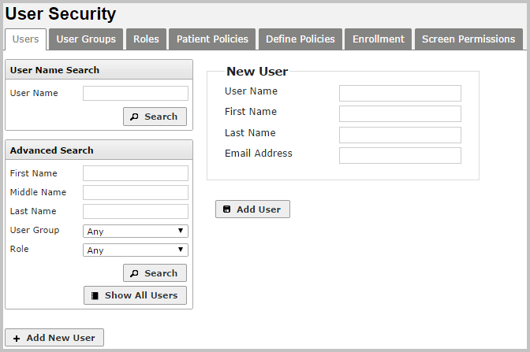

### Importing Users

Large numbers of users can be added to the system using the *Import Users* function of the **Users** tab.

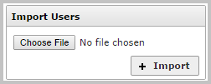

Information about users must be compiled in a comma-delimited text file (saved as a .csv file). The file must be set up as follows:

* Field 1: User name (required)
* Field 2: First name
* Field 3: Last name
* Field 4: Credentials
* Field 5: Email address (required)
* Field 6: Institution code

Note: Multiple institutions can be listed by separating them with a pipe character.

* Field 7: User group code (required)
* Field 8: Roles

Note: Multiple roles can be listed by separating them with a pipe character.

Any Institution, User Group, or Role being assigned must already exist in the system.

Note: The Institutions and User Group values currently expected are codes, not names. For more information about codes, contact the deployment team.

Here are two examples of user profiles for Joe Smith and Fred Jones using the correct CSV format:

jsmith,Joe,Smith,MD,joe_smith@email.com,HospitalA,Physicians,Clinician fjones,Fred,Jones,,fred@email.com,HospitalA|HospitalB,Master User Group,Admin|PowerUser